
We would like to share some employees input regarding the Dividend’s checks received:

ESOP DIVIDEND CHECK | What was your reaction when you saw the check? | Do you have special plans on what to do with the money? | What do you need to do to make your company shares grow in value?
  Lorenzo Perez, IE | “I was pleased to realize that ESOP is a good benefit.” | “I’ll spend it in several things. I didn’t expect to get this check and it was very good!” | “First of all, be safe at work. We need to take care of the tools and do our job as best as we possibly can so the clients can give us more work.”
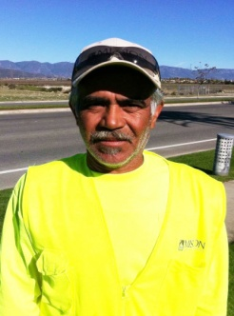  Jose F. Meza, IE | “It was a surprise! I never expected it!” | “Oh Yes! I will save it for my vacations.” | “Help the company by taking care of the equipment; taking very good care of the jobsites; and work safely to avoid accidents.”
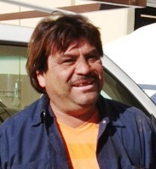  Ignacio “Nacho” Garcia, Fleet | "I was very happy...muy bien" | "Yes, I will now be able to invest it into my truck and fix it up." | "Keep working hard and be safe.”
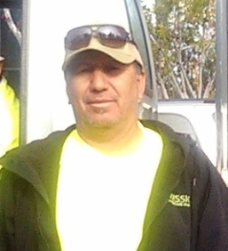  Raul de Alba, IE | “I got very excited when I opened the check, I felt appreciated by my company and that all my hard work is paying off.” | “I am planning on using this money to pay for my son’s college books.” | “Continue working smart and hard for the company.”
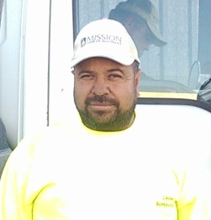  Ariel Parra, IE | “I was very happy when I saw the amount on the check.” | “I have decided to use it during my vacations.” | “To continue working hard making sure the work quality is above 90% and repotting issues on the properties.”
ESOP is very good for you because it will give you a better future.

